# **BASIC SKIING TIPS**

# **HOW TO IMPROVE YOUR SKI TECHNIQUE**

# **SKIING THROUGH TOUGH TERRAIN**

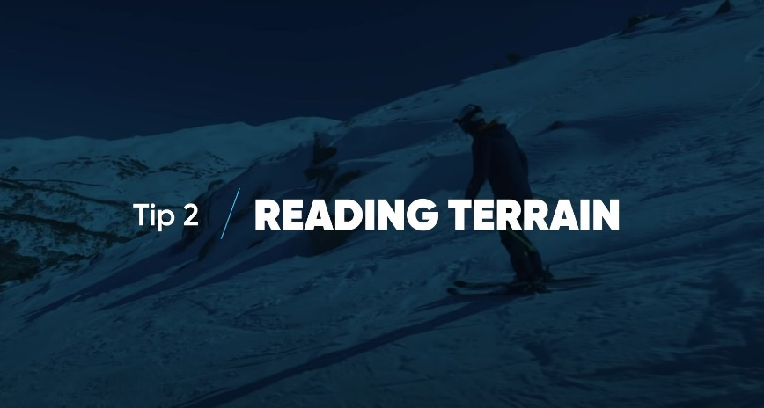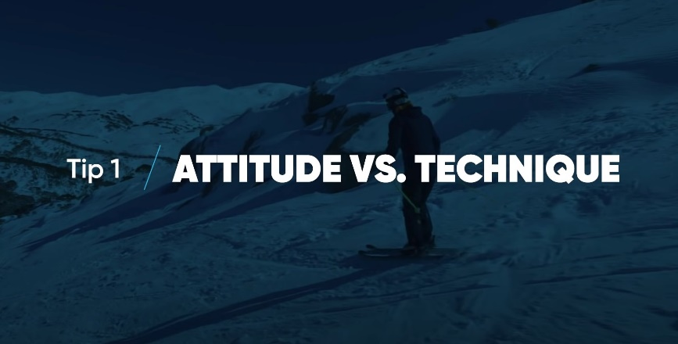

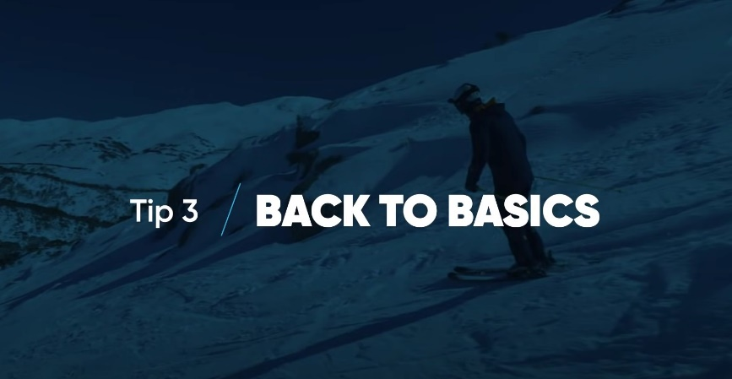

# **5 TURN TYPES**

